
SIMATS ENGINEERING
Saveetha Institute of Medical and Technical Sciences
Chennai-602105

AI-Powered Smart Classroom Monitoring and Learning Analytics Platform.
CO3 ASSESSMENT TOOL 1 – Git and Docker Technical Assignment
Submitted in the partial fulfilment for the Course of
CSA1012-SOFTWARE ENGINEERING
to the award of the degree of
BACHELOR OF ENGINEERING
IN
CS AND BIOSCIENCE
Submitted by
G AAMNA KHAN(192371084)
Under the Supervision of
ANITADAVAMANI

1. PROBLEM ANALYSIS

1.1 Problem Statement
Traditional classroom management mainly depends on manual attendance, teacher observations, marks, and periodic examinations. These methods provide limited information about the overall learning behaviour and academic performance of students.
The proposed AI-Powered Smart Classroom Monitoring and Learning Analytics Platform is designed to collect classroom and academic data and use Artificial Intelligence and Machine Learning techniques to generate meaningful learning insights.
The system provides a centralized platform where teachers can monitor attendance, student performance, learning activities, assessment results, and engagement indicators. AI-based analytics can identify students who may require additional academic support and generate performance predictions or recommendations.
The platform is designed using a modern full-stack architecture and is containerized using Docker. Git is used for source-code management, collaboration, version control, and maintaining different development versions.

1.2 Project Objectives
The major objectives are:
- To develop a centralized smart classroom monitoring platform.
- To digitally maintain student attendance and academic information.
- To analyze student performance using AI/ML techniques.
- To identify students who may require additional academic support.
- To provide dashboards for teachers and administrators.
- To generate learning analytics and performance reports.
- To maintain the application source code using Git.
- To containerize application components using Docker.
- To provide a reproducible development and deployment environment.
- To improve scalability, portability, and maintainability.

1.3 Functional Requirements

Student Module
- Student registration and login.
- View attendance.
- View marks and assessment results.
- View performance analytics.
- View learning recommendations.

Faculty Module
- Faculty login.
- Add and manage students.
- Record attendance.
- Enter assessment marks.
- View student performance.
- View AI-generated learning insights.
- Generate reports.

AI/Analytics Module
- Analyze attendance.
- Analyze assessment performance.
- Calculate performance indicators.
- Identify students requiring attention.
- Predict possible academic performance.
- Generate learning recommendations.

Administrator Module
- Manage students and faculty.
- Manage classroom information.
- Monitor system activity.
- View overall analytics.

System Requirements
- Authentication and authorization.
- Database storage.
- REST API.
- Responsive web interface.
- AI/ML analytics.
- Containerized deployment.

1.4 Non-Functional Requirements

Performance
The system should respond quickly to user requests and efficiently process classroom data.

Scalability
The application should support an increasing number of students, faculty members, and classroom records.

Security
User credentials and academic information should be protected using authentication, authorization, secure password handling, and environment variables.

Reliability
The system should provide consistent results and minimize data loss.

Maintainability
The source code should be modular and maintained using Git.

Portability
The application should be executable on different systems using Docker.

1.5 Expected Outcomes
The expected outcome is a full-stack smart classroom platform capable of:
- Managing student information.
- Managing attendance.
- Managing assessments.
- Analyzing learning performance.
- Providing AI-based insights.
- Displaying teacher dashboards.
- Storing data in a database.
- Running consistently using Docker containers.

2. PROJECT STRUCTURE DESIGN
The proposed repository structure is:
smart-classroom/
│
├── frontend/
│ ├── src/
│ ├── public/
│ ├── package.json
│ └── Dockerfile
│
├── backend/
│ ├── app/
│ │ ├── main.py
│ │ ├── models/
│ │ ├── routes/
│ │ ├── services/
│ │ └── ml/
│ ├── requirements.txt
│ └── Dockerfile
│
├── database/
│ └── init.sql
│
├── tests/
│ ├── test_api.py
│ └── test_ml.py
│
├── docs/
│ ├── architecture.png
│ └── workflow.png
│
├── .gitignore
├── .env
├── .env.example
├── docker-compose.yml
├── README.md
└── LICENSE

2.1 Folder Explanation
Folder/File | Purpose
frontend/ | Contains the user interface
backend/ | Contains server-side application logic
models/ | Contains database models
routes/ | Contains API endpoints
services/ | Contains application/business logic
ml/ | Contains AI/ML analytics
database/ | Contains database initialization scripts
tests/ | Contains automated tests
docs/ | Contains diagrams and documentation
.gitignore | Specifies files Git should ignore
.env | Stores environment-specific configuration
.env.example | Provides example environment variables
Dockerfile | Defines container image instructions
docker-compose.yml | Defines and manages multiple containers
README.md | Contains project documentation

3. GIT REPOSITORY INITIALIZATION
Git is used as the version control system for the project. It tracks changes made to source code and allows different versions of the project to be maintained.

3.1 Git Initialization
Create the project folder:
mkdir smart-classroom
cd smart-classroom
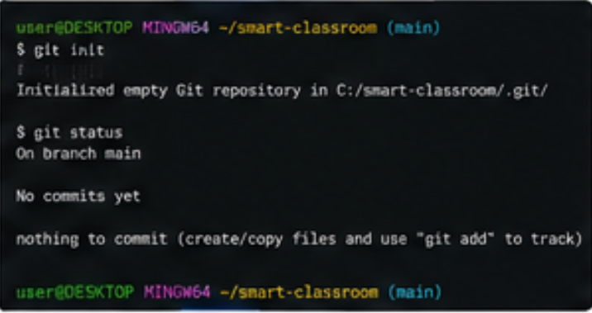

3.2 Essential Git Files

.git/
The .git directory contains Git’s internal repository information, including commit history, branches, configuration, and object data.

.gitignore
The .gitignore file prevents unnecessary or sensitive files from being committed.
Example:
node_modules/
__pycache__/
.env
*.pyc
dist/
build/

README.md
Contains information about the project, installation procedure, architecture, Git workflow, Docker commands, and usage.
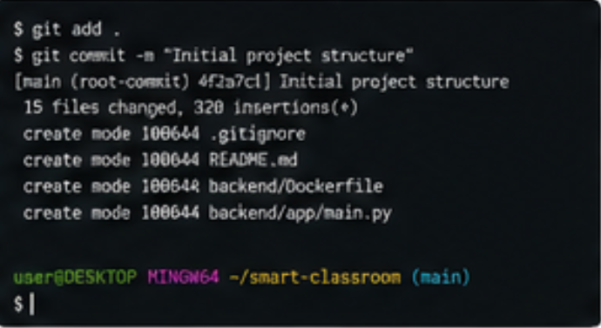

4. GIT BRANCHING STRATEGY
A Git Flow-inspired branching strategy is selected for this project.
main
│
development
/ | \
feature feature feature
/student /ai /dashboard
\ | /
\ | /
development
│
release
│
main

4.1 Main Branch
The main branch contains stable and tested versions of the application.
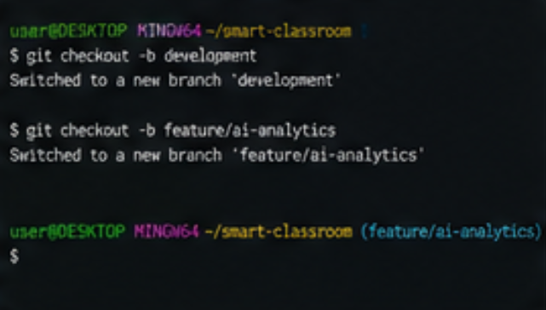

4.2 Development Branch
The development branch integrates completed features before they are released.

4.3 Feature Branch
Each major feature is developed in a separate branch.
Examples:
feature/student-module
feature/ai-analytics
feature/dashboard
feature/authentication

4.4 Release Branch
A release branch is created when a stable version is ready for testing and deployment.
Example:
release/v1.0

4.5 Hotfix Branch
A hotfix branch is used for critical bugs found in the production version.
Example:
hotfix/login-error

Justification
This strategy is suitable because the project contains several independent components such as authentication, dashboards, AI analytics, database integration, and Docker deployment. Feature branches allow these components to be developed independently without directly affecting the stable code.

5. VERSION CONTROL WORKFLOW

5.1 Create Development Branch
git checkout -b development

5.2 Create a Feature Branch
git checkout -b feature/ai-analytics

5.3 Add Changes
git add .

5.4 Commit Changes
git commit -m "Add AI performance analytics module"

5.5 Push Feature Branch
git push -u origin feature/ai-analytics

5.6 Merge Feature Branch
Move to development:
git checkout development
Merge:
git merge feature/ai-analytics
Push changes:
git push origin development

5.7 Synchronizing Repository
Before starting new work:
git pull origin development
After completing work:
git add .
git commit -m "Update student analytics dashboard"
git push origin development

5.8 Conflict Resolution
If Git reports a merge conflict:
git status
Open the conflicting file and resolve the conflict manually.
Then:
git add .
git commit -m "Resolve merge conflict"
The resolved changes can then be pushed to the remote repository.

5.9 Git Workflow Diagram
GitHub Repository
│
▼
main
│
▼
development
/ | \
▼ ▼ ▼
feature feature feature
/login /AI /dashboard
\ | /
\ | /
▼ ▼ ▼
development
│
▼
release
│
▼
main

6. COMMIT HISTORY ANALYSIS
Meaningful commit messages are important because they explain what changes were introduced.
Example commit history:
a81d2c1 Add Docker Compose configuration
b42ef91 Add AI performance analytics
c19a842 Implement student dashboard
d31b776 Add attendance API
e52c611 Add PostgreSQL database models
f72d301 Implement user authentication
g83a452 Create backend API structure
h91b632 Create frontend project structure
i21c743 Initial project structure
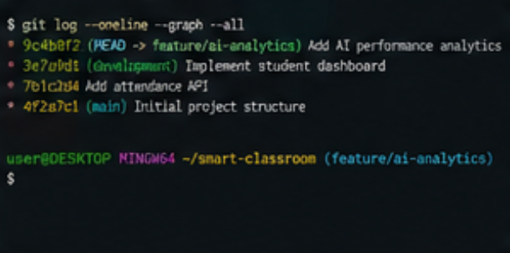

MERGE FEATURE TO DEVELOPMENT
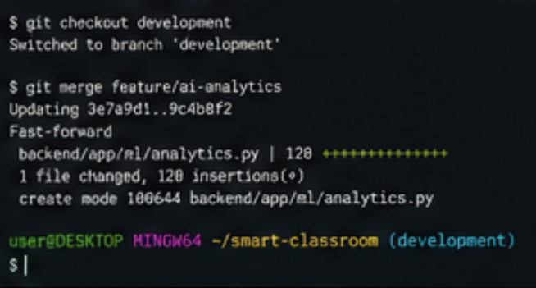
DOCKER FILE
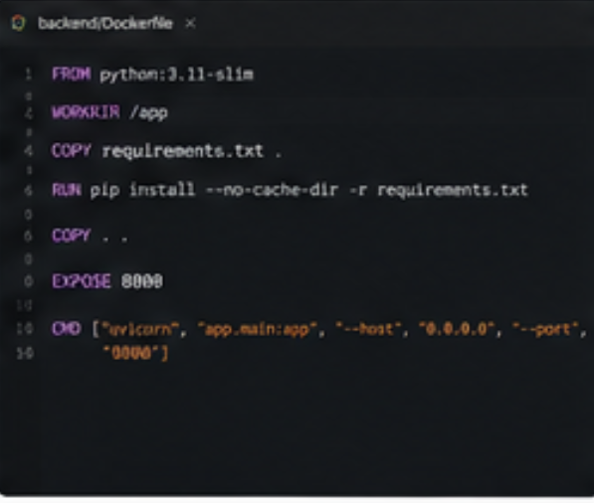

DOCKER COMPOSE FILE
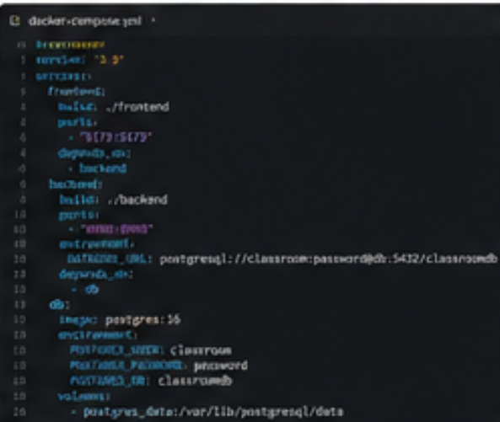
BUILD DOCKER IMAGES
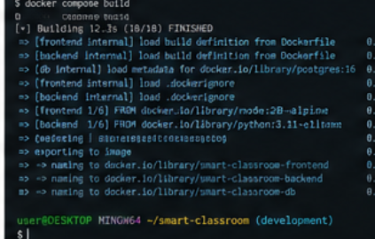
RUN DOCKER COMPOSE
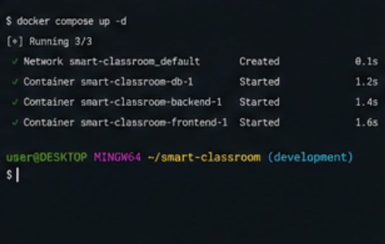
RUNNING CONTAINERS
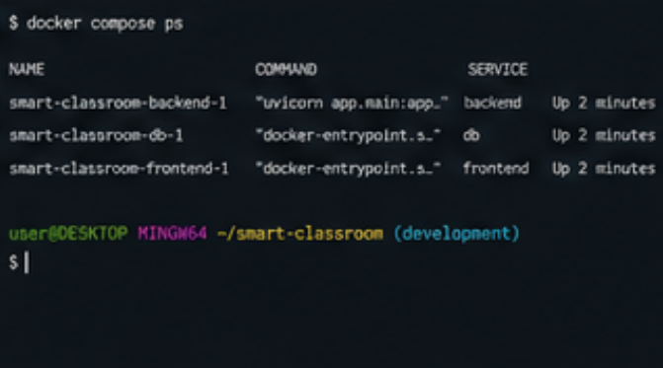

Good Commit Message Practices
Commit messages should:
- Be short and descriptive.
- Use action-oriented language.
- Describe one logical change.
- Avoid vague messages such as changes, update, or final.
Examples:
Add student attendance API
Implement performance prediction
Fix database connection error
Update Docker backend configuration
Add faculty dashboard
To display history:
git log --oneline --graph --all
This command provides a compact visual representation of commits and branches.

7. DOCKER ENVIRONMENT DESIGN
Docker is a containerization platform that packages an application together with its dependencies into isolated containers.
Docker is suitable for this project because the platform contains multiple components:
- Frontend.
- Backend/API.
- PostgreSQL database.
- AI/ML processing.
Instead of installing every dependency manually, Docker provides a consistent execution environment.

7.1 Proposed Architecture
USER
│
▼
┌─────────────────────┐
│ Web Frontend │
│ React / Web UI │
└──────────┬──────────┘
│ HTTP/REST
▼
┌─────────────────────┐
│ Backend API │
│ FastAPI / Python │
└───────┬───────┬─────┘
│ │
│ ▼
│ ┌───────────────┐
│ │ AI/ML Module │
│ │ Analytics │
│ └───────────────┘
│
▼
┌─────────────────────┐
│ PostgreSQL Database │
└─────────────────────┘

7.2 Components Requiring Containerization

Frontend Container
Runs the web interface.

Backend Container
Runs the REST API and application logic.

Database Container
Runs PostgreSQL and stores application data.

AI/ML Component
The AI/ML functionality can be packaged inside the backend container for a small deployment or separated into an independent ML service for a larger scalable deployment.
For this academic implementation, integrating the ML module with the backend keeps the architecture simple while still demonstrating containerization.

8. DOCKERFILE DEVELOPMENT

8.1 Backend Dockerfile
FROM python:3.11-slim
WORKDIR /app
COPY requirements.txt .
RUN pip install --no-cache-dir -r requirements.txt
COPY . .
EXPOSE 8000
CMD ["uvicorn", "app.main:app", "--host", "0.0.0.0", "--port", "8000"]

8.2 Explanation of Instructions

FROM
FROM python:3.11-slim
Specifies the base Python image.

WORKDIR
WORKDIR /app
Sets /app as the working directory inside the container.

COPY
COPY requirements.txt .
Copies the Python dependency file into the container.

RUN
RUN pip install --no-cache-dir -r requirements.txt
Installs all required Python packages.

COPY
COPY . .
Copies the backend application into the container.

EXPOSE
EXPOSE 8000
Documents the port used by the backend application.

CMD
CMD ["uvicorn", "app.main:app", "--host", "0.0.0.0", "--port", "8000"]
Starts the FastAPI application.

8.3 Frontend Dockerfile
FROM node:20-alpine
WORKDIR /app
COPY package*.json ./
RUN npm install
COPY . .
EXPOSE 5173
CMD ["npm", "run", "dev", "--", "--host", "0.0.0.0"]
This Dockerfile creates an environment for running the frontend application.

9. DOCKER COMPOSE DESIGN
Docker Compose is used to define and run multiple containers as a single application.

9.1 docker-compose.yml
services:
frontend:
build: ./frontend
ports:
- "5173:5173"
depends_on:
- backend
backend:
build: ./backend
ports:
- "8000:8000"
environment:
DATABASE_URL: postgresql://classroom:password@db:5432/classroomdb
depends_on:
- db
db:
image: postgres:16
environment:
POSTGRES_USER: classroom
POSTGRES_PASSWORD: password
POSTGRES_DB: classroomdb
volumes:
- postgres_data:/var/lib/postgresql/data
volumes:
postgres_data:

9.2 Services

Frontend
Provides the graphical user interface.

Backend
Provides APIs, business logic, authentication, and AI analytics.

Database
PostgreSQL stores:
- Student information.
- Faculty information.
- Attendance.
- Assessment marks.
- Learning activity.
- Analytics results.

9.3 Networking
Docker Compose creates a common network for the services.
The backend can communicate with PostgreSQL using:
db:5432
The backend does not need to use localhost to access the database because the containers communicate through the Docker network.

9.4 Volumes
volumes:
- postgres_data:/var/lib/postgresql/data
The volume ensures that PostgreSQL data remains available even when the database container is recreated.

9.5 Environment Variables
Database configuration is supplied through environment variables.
Example:
DATABASE_URL
POSTGRES_USER
POSTGRES_PASSWORD
POSTGRES_DB
Sensitive values should not be directly committed to Git. The .env file should be included in .gitignore.

9.6 Service Dependencies
The backend depends on the database:
depends_on:
- db
The frontend depends on the backend:
depends_on:
- backend
This establishes the expected startup relationship between services.

10. CONTAINER DEPLOYMENT AND TESTING

10.1 Build the Containers
From the project root:
docker compose build
This builds the required images using the Dockerfiles.

10.2 Start the Application
docker compose up
For background execution:
docker compose up -d

10.3 Check Running Containers
docker compose ps
Expected services:
frontend
backend
db

10.4 View Logs
docker compose logs
Backend logs:
docker compose logs backend
Database logs:
docker compose logs db

10.5 Stop Containers
docker compose down

10.6 Testing Procedure
The following tests can be performed:

Test 1 – Frontend
Open the frontend application in a browser and verify that the dashboard loads.

Test 2 – Backend
Verify that the backend API is accessible.
For FastAPI, the API documentation can be accessed through:
http://localhost:8000/docs

Test 3 – Database
Verify that the backend can establish a connection with PostgreSQL.

Test 4 – Student Data
Add a student and verify that the information is stored.

Test 5 – Attendance
Record attendance and verify that the attendance percentage is calculated.

Test 6 – AI Analytics
Enter sample attendance and assessment information and verify that the analytics module generates a performance insight.

Test 7 – Docker
Verify that all containers are running:
docker compose ps

10.7 Screenshots to Include
The following screenshots should be added to the final report:
Screenshot 1: git init and git status
Screenshot 2: GitHub repository
Screenshot 3: Branch creation
Screenshot 4: Git commit history
Screenshot 5: Git merge operation
Screenshot 6: Docker image build
Screenshot 7: docker compose up
Screenshot 8: docker compose ps
Screenshot 9: Application dashboard
Screenshot 10: API documentation
Screenshot 11: AI analytics result
These screenshots provide evidence that the project was actually implemented and tested.

11. BENEFITS OF GIT AND DOCKER

11.1 Collaboration
Git allows multiple developers to work on different features using separate branches.
For example:
Developer 1 → Authentication
Developer 2 → AI Analytics
Developer 3 → Dashboard
Developer 4 → Docker/Deployment
Their changes can later be merged into the development branch.

11.2 Version Management
Git maintains a complete history of changes. If a new version introduces an error, the team can identify the responsible commit and restore an earlier version.

11.3 Portability
Docker allows the application to run consistently on different systems without manually installing all dependencies.

11.4 Deployment
The same Docker configuration can be used during development, testing, and deployment.

11.5 Scalability
The application is divided into services, allowing components to be scaled independently.
For example, if the backend receives a large number of requests, additional backend containers can be deployed.

11.6 Maintainability
Git provides structured source-code management, while Docker provides isolated and reproducible environments. Together they simplify maintenance.

11.7 Dependency Management
Docker packages application dependencies inside containers, reducing dependency-related errors.

12. CHALLENGES AND IMPROVEMENTS

12.1 Challenges Encountered

Dependency Issues
Different versions of Python packages may produce compatibility problems.
Solution: Specify dependency versions in requirements.txt.

Database Connectivity
The backend must correctly communicate with the PostgreSQL container.
Solution: Use the Docker Compose service name db rather than localhost.

Git Merge Conflicts
Multiple developers modifying the same file can produce merge conflicts.
Solution: Frequently pull changes, keep commits small, and resolve conflicts carefully.

Environment Configuration
Database passwords and configuration values should not be stored directly in source code.
Solution: Use environment variables and .env files.

AI Model Accuracy
AI-based predictions depend on the quality and quantity of available data.
Solution: Use larger datasets, appropriate preprocessing, model evaluation, and continuous improvement.

Container Resource Usage
Running multiple containers can consume system resources.
Solution: Use lightweight images and optimize application dependencies.

12.2 Future Enhancements
The following improvements can be implemented in future versions:
- Real-time classroom analytics.
- Advanced student performance prediction.
- Personalized learning recommendations.
- Mobile application support.
- Cloud deployment.
- Automated CI/CD using GitHub Actions.
- Role-based access control.
- Advanced analytics dashboards.
- Notification system for faculty.
- Automated report generation.
- Model monitoring and retraining.
- Integration with existing Learning Management Systems.
- Improved privacy and access-control mechanisms.
- Horizontal scaling of backend services.
- Centralized application logging and monitoring.

13. SYSTEM ARCHITECTURE
The complete system can be represented as:
┌──────────────────────┐
│ STUDENTS │
└──────────┬───────────┘
│
▼
┌──────────────────────┐
│ Web Interface │
│ React / Frontend │
└──────────┬───────────┘
│
HTTP / REST
│
▼
┌──────────────────────┐
│ Backend API │
│ FastAPI │
└──────┬────────┬──────┘
│ │
┌───────────┘ └────────────┐
▼ ▼
┌──────────────────┐ ┌──────────────────┐
│ PostgreSQL │ │ AI/ML Analytics │
│ Database │ │ Performance │
└──────────────────┘ └──────────────────┘
│
▼
┌──────────────────┐
│ Insights & │
│ Recommendations │
└──────────────────┘
┌──────────────────────┐
│ FACULTY │
└──────────┬───────────┘
│
▼
Faculty Analytics
& Monitoring Dashboard

14. COMPONENT INTERACTION
The major interaction sequence is:
Student/Faculty
│
▼
Frontend
│
▼
Backend API
│
├──────────────► PostgreSQL
│
▼
AI/ML Analytics
│
▼
Performance Analysis
│
▼
Dashboard
│
▼
Insights / Recommendations
For example, when a faculty member enters assessment marks:
- The faculty enters marks through the frontend.
- The frontend sends the information to the backend.
- The backend validates the information.
- The information is stored in PostgreSQL.
- The analytics module processes the student’s academic data.
- The system calculates performance indicators.
- The result is displayed on the dashboard.

15. QUALITY ATTRIBUTE ANALYSIS

Performance
The system should process student data efficiently and provide dashboard information with low response time.

Scalability
The application can be separated into containers, allowing individual services to scale according to demand.

Security
Authentication, authorization, encrypted communication, secure passwords, and environment variables can be used to protect data.

Availability
Dockerized services can be restarted independently when failures occur.

Maintainability
Git branches and modular application components make the project easier to modify.

Portability
Docker ensures that the application has a consistent runtime environment across development and deployment systems.

Reliability
Database persistence through Docker volumes reduces the risk of losing stored data when containers are recreated.

16. COMPLETE GIT WORKFLOW
The complete workflow followed by the project is:
Create Project
│
▼
git init
│
▼
Initial Commit
│
▼
Create Development Branch
│
▼
Create Feature Branch
│
▼
Develop Feature
│
▼
git add
│
▼
git commit
│
▼
git push
│
▼
Code Review / Testing
│
▼
Merge to Development
│
▼
Integration Testing
│
▼
Release Branch
│
▼
Merge to Main
│
▼
Deployment

17. COMPLETE DOCKER WORKFLOW
Source Code
│
▼
Dockerfile
│
▼
Docker Image
│
▼
Docker Compose
│
├──────────────┐
▼ ▼
Frontend Backend
│
▼
Database
│
▼
AI Analytics
│
▼
Final Output

18. CONCLUSION
The AI-Powered Smart Classroom Monitoring and Learning Analytics Platform provides a modern approach to classroom management and academic analysis. The platform combines a full-stack application with AI-based learning analytics to help faculty understand student attendance, academic performance, and learning patterns.
Git provides an effective version-control mechanism for maintaining the project source code. The use of feature branches, meaningful commits, merging, synchronization, and release management supports collaborative software development.
Docker provides a consistent and portable execution environment for the frontend, backend, and database components. Docker Compose simplifies the management of multiple services and allows the complete application to be started using a single configuration.
The combination of Git and Docker improves collaboration, portability, deployment, scalability, version management, and maintainability. Future versions can incorporate advanced machine learning models, cloud deployment, CI/CD automation, real-time analytics, mobile applications, and improved privacy mechanisms.
Therefore, the proposed system demonstrates how modern software engineering practices can be applied to develop, manage, containerize, and deploy an AI-powered smart classroom platform.

19. REFERENCES
- Pro Git, Scott Chacon and Ben Straub.
- Git Documentation – Version Control and Git Commands.
- Docker Documentation – Containers and Docker Compose.
- Python Documentation.
- FastAPI Documentation.
- PostgreSQL Documentation.
- React Documentation.
- General concepts of Machine Learning and Learning Analytics.

20. FINAL DELIVERABLE CHECKLIST
- 10-page technical report
- Git repository
- Complete commit history
- Source code
- .gitignore
- README.md
- Backend Dockerfile
- Frontend Dockerfile
- docker-compose.yml
- Database configuration
- Architecture diagram
- Git workflow diagram
- Docker workflow diagram
- Git initialization screenshot
- Branching screenshot
- Commit history screenshot
- Merge screenshot
- Docker build screenshot
- Docker Compose execution screenshot
- Running containers screenshot
- Application dashboard screenshot
- AI analytics output screenshot
- Testing evidence

